

Dayananda Sagar College of Engineering

Shavige Malleshwara Hills, Kumaraswamy Layout, Bangalore -5600078

(An Autonomous Institute Affiliated to VTU Approved by AICTE & ISO 9001:2015 Certified Accredited by National Assessment & Accreditation Council (NAAC) with ‘A’ Grade)

# Travel Photography Portfolio

A Mini Project Report on Web Technology

*Submitted in partial fulfilment of the requirements for the Award of MCA degree*

**Master of Computer Applications**

**Submitted to**

**Dayananda Sagar College of Engineering**

**Submitted By**

**VARUN M (1DS21MC117)**

**Supervised By**

**Dr. Vibha M B**

# CERTIFICATE

I hereby certify that the work which is being presented in the MCA, mini project report entitled **‘Travel Photography Portfolio’,** in partial fulfillment of the requirements for the award of the MCA and submitted to the **Department of MCA,**

**Dayananda Sagar College of Engineering, Bangalore** is an authentic record of my own work carried out during the period of Oct-2022 (II Semester) under the supervision of **Dr. Vibha M B, Department of MCA.**

The matter presented in this project report has not submitted by me for the award of any other degree elsewhere.

**Signature of Student**

This is to certify that the above statement made by the students is correct to the best of my knowledge

**Signature of Supervisor Signature of HOD**

**Dr. Vibha M B Dr. Samitha Khaiyum**

Examiners **Name : VARUN M**

1 : ……………………. **USN : 1DS21MC117**

2:…………………….. **Examination Centre :**

**Exam Date :**

ACKNOWLEDGEMENT

I would like to place on my record my deep sense of gratitude to

**Dr. Samitha Khaiyum**, HOD Department of MCA, Dayananda Sagar College of Engineering Bangalore, india for the generous guidance, help and useful suggestions

I express my sincere gratitude to **Dr. Vibha M B,** Department of

MCA, Dayananda Sagar College of Engineering, Bangalore, India for her stimulating guidance, continuous encouragement and supervision throughout the course of present work.

**Signature of Student**

## Table of Contents

**Acknowledgement…………………………………………………….3**

**List of Tables……………………………………………………………..4**

1. **Introduction……………………………………………………… 5** 
   1. Contents**………………………………………………5**

1. **Implementation……………………………………………….....9**
   1. Home Page………………………………………………………9
   2. Style sheet………………………………………………………18
   3. Stories Page……………………………………………………..26
2. **Screenshots of Output………………………………………...30**
3. **Tools and technologies……………………………………….35**

1. **Conclusion…………………………………………………………..36**
   1. Limitations and Future Enhancements

1. **Bibliography……………………………………………………….37**

***CONTENTS***

|  |  |  |  |
| --- | --- | --- | --- |
| Sl. No |  | Topic | Page. No |
| 1. | Introduction |  | 06 |
| 2. | Objective & Purpose |  | 07 |
| 3. | Modules |  | 08 |
| 4. | Code Implementation |  | 09 |
| 5. | Tools and technologies |  | 35 |
| 6. | Limitations & future changes |  | 36 |
| 7. | Bibliography |  | 37 |

**Introduction**

Besides cameras and lenses, photographers and camera operators employ a variety of film and filters to obtain the desired effect under different lighting conditions. When taking pictures indoors or after dark, they may use electronic flash units, floodlights, reflectors, and other special lighting equipment and backdrops.

Some photographers develop and print their own photographs in the darkroom and may enlarge or otherwise alter the basic image. Many photographers send their work to laboratories for processing.

Employment of photographers and camera operators is expected to grow faster than the average for all occupations through the year 2000. Many additional job openings will occur as workers transfer to other occupations or stop working.

Each customer has their own individual requirements and characteristics.

Most of the Photographers portfolio do not give more details about their experience on travelling to those mentioned places, instead they mention only some attractive details to gather customer attention.

Program graduates need to develop interpersonal relations skills in the areas of customer sales and service. Graduates should be prepared for entrepreneurial or free-lance business operations.

**Objectives**

Here we mainly focused on researching the occupation, establishing appropriate committees, and conducting task verification. The results of this phase have provided the basic information required to develop the program standards and guide and set up the committee structure to guide the project. The program is designed to address the needs of the Travel photography field that use or plan to use graduates as photographic technicians.

**Purpose**

* Access to the Travel Photography details from the website.
* Offer users to learn the behaviour customs, traditions and as well as different culture of different places across the world.
* Enthusiasm for lifelong learning.
* Socialization, Inter-Communications and Value of Education.

**Modules**

* **Home**

List of all the facilities provided by the us.

It shows the basic information about the author.

* **Gallery**

It contains the collection of Images and videos all to together to form a beautiful gallery The people search the places for their necessary requirements.

* **Stories**

It mainly contains different blogs that shows the details about the culture, traditions and route guide for their respective places.

* **Contact**

The users can contact for any queries,

also people can provide the feedback about their experience..

***Code Implementation***

**index.html**

<!DOCTYPE html>

<html lang="en">

<head>

<meta charset="UTF-8">

<meta name="viewport" content="width=device-width, initial-scale=1.0">

<title>mvk.in</title>

<!-- CSS only -->

<link href="https://cdn.jsdelivr.net/npm/bootstrap@5.2.2/dist/css/bootstrap.min.css" rel="stylesheet" integrity="sha384-Zenh87qX5JnK2Jl0vWa8Ck2rdkQ2Bzep5IDxbcnCeuOxjzrPF/et3URy9Bv1WTRi" crossorigin="anonymous">

<!-- JavaScript Bundle with Popper -->

<script src="https://cdn.jsdelivr.net/npm/bootstrap@5.2.2/dist/js/bootstrap.bundle.min.js" integrity="sha384-OERcA2EqjJCMA+/3y+gxIOqMEjwtxJY7qPCqsdltbNJuaOe923+mo//f6V8Qbsw3" crossorigin="anonymous"></script>

<link rel="stylesheet" href="style.css">

<!-- Form validation-->

<script src="https://ajax.googleapis.com/ajax/libs/jquery/3.5.1/jquery.min.js"></script>

<script src="https://cdn.jsdelivr.net/jquery.validation/1.16.0/jquery.validate.min.js"></script>

<script src="https://cdn.jsdelivr.net/jquery.validation/1.16.0/additional-methods.min.js"></script>

<script src="https://kit.fontawesome.com/dbed6b6114.js" crossorigin="anonymous"></script>

</head>

<body>

<!-- header section start -->

<div class="header">

<h2><a href="#main">MVK</a></h2>

<ul>

<li><a href="#main">HOME</a></li>

<li><a href="#gallery">GALLERY</a></li>

<li><a href="stories.html">STORIES</a></li>

<li><a href="#contact">CONTACT</a></li>

</ul>

</div>

<!-- header section end -->

<!-- main section start -->

<div class="container-fluid" id="main">

<div class="row justify-content-center align-items-center" style="width:100%;">

<div class="col-lg-3 text-center">

<h1 style="color: greenyellow">VARUN MITHYANTHA</h1>

<h5>photographer || Traveller</h5>

<br><br>

</div>

<div class="row justify-content-center" >

<div class="col-6" id="text">"To me, photography is an art of observation. It’s about finding something interesting in an ordinary place… I’ve found it has little to do with the things you see and everything to do with the way you see them."</div>

</div>

</div>

<div class = "social-icons">

<ul>

<li>

<a href = "https://www.facebook.com/profile.php?id=100071594053991/" target="_blank"><i class="fab fa-facebook-f"></i></a>

</li>

<li>

<a href = "https://www.instagram.com/varun.mithyantha/" target="_blank"><i class="fa fa-instagram"></i></a>

</li>

<li>

<a href = "https://www.linkedin.com/in/varun-mithyantha/" target="_blank"><i class="fab fa-linkedin"></i></a>

</li>

</ul>

</div>

</div>

<!-- main section end -->

<!-- home section start -->

<!-- home section end -->

<!-- gallery section start -->

<div class="container"id="gallery">

<br><br><br>

<h2>GALLERY</h2>

<br>

<div class="container px-4 text-center">

<div class="row gx-5 mb-3">

<div class="col-xs-3 col-lg-3 mb-3" class>

<img src="images/g1.JPG" alt="">

<span>Talasi Abbi Falls</span>

</div>

<div class="col-xs-3 col-lg-3 mb-3" class>

<img src="images/g2.jpeg" alt="">

<span>Homestay</span>

</div>

<div class="col-xs-3 col-lg-3 mb-3" class>

<img src="images/g6.JPG" alt="">

<span>Barkur Fort</span>

</div>

<div class="col-xs-3 col-lg-3 mb-3" class>

<img src="images/g4.JPG" alt="">

<span>Yaana Caves</span>

</div>

</div>

<div class="row gx-5 mb-3">

<div class="col-xs-3 col-lg-3 mb-3" class>

<img src="images/g5.JPG" alt="">

<span>Cats</span>

</div>

<div class="col-xs-3 col-lg-3 mb-3" class>

<img src="images/g9.jpeg" style="height: 160px;" alt="">

<span>Kapu Beach</span>

</div>

<div class="col-xs-3 col-lg-3 mb-3" class>

<img src="images/g7.jpg" alt="">

<span>Belkaltheertha Falls</span>

</div>

<div class="col-xs-3 col-lg-3 mb-3" class>

<img src="images/g8.jpg" alt="">

<span>Muduru</span>

</div>

</div>

<div class="row gx-5 mb-3">

<div class="col-xs-3 col-lg-3 mb-3" class>

<img src="images/g3.jpeg" style="height: 180px;" alt="">

<span>Kodi Beach</span>

</div>

<div class="col-xs-3 col-lg-3 mb-3" class>

<video width="300" height="200" controls>

<source src="images/g10.mp4" type="video/mp4">Your browser does not support the video tag</video>

<span>Jaggery Extraction</span>

</div>

<div class="col-xs-3 col-lg-3 mb-3" class>

<video width="300" height="200" controls>

<source src="images/g11.mp4" type="video/mp4">Your browser does not support the video tag</video>

<span>Abbi Falls</span>

</div>

<div class="col-xs-3 col-lg-3 mb-3" class>

<video width="300" height="200" controls>

<source src="images/g12.mp4" type="video/mp4">Your browser does not support the video tag</video>

<span>Trailer</span>

</div>

</div>

</div>

</div>

<!-- gallery section end -->

<div class="container" id="contact">

<br><br><br>

<h2>CONTACT ME</h2>

<br>

<form class="row g-3" id="send_message" action="mailto:varunmithyantha.photography@gmail.com">

<div class="col-lg-3"></div>

<div class="form-group col-lg-6 col-sm-12">

<label>Name</label>

<input type="text" name="name" id="name" class="form-control" required onkeypress="return Validate(event);" />

<span id="err" style="color: red;"></span>

<!-- Name Validation start -->

<script type="text/javascript">

function Validate(e) {

var keyCode = e.keyCode || e.which;

var lblError = document.getElementById("err");

lblError.innerHTML = "";

//Regex for Valid Characters i.e. Alphabets.

var regex = /^[A-Za-z ]+$/;

//Validate TextBox value against the Regex.

var isValid = regex.test(String.fromCharCode(keyCode));

if (!isValid) {

lblError.innerHTML = "Only Alphabets allowed.";

}

return isValid;

}

</script>

<!-- Name Validation end -->

</div>

<div class="col-lg-3"></div>

<div class="col-lg-3"></div>

<div class="form-group col-lg-6 col-sm-12">

<label>Email</label>

<input type="text" id="txtEmail" name="email" class="form-control email_form" required onkeyup="ValidateEmail();" />

<span id="lblError" style="color: red;"></span>

<!-- Email Validation start-->

<script type="text/javascript">

function ValidateEmail() {

var email = document.getElementById("txtEmail").value;

var lblError = document.getElementById("lblError");

lblError.innerHTML = "";

var expr = /^([\w-\.]+)@((\[[0-9]{1,3}\.[0-9]{1,3}\.[0-9]{1,3}\.)|(([\w-]+\.)+))([a-zA-Z]{2,4}|[0-9]{1,3})(\]?)$/;

if (!expr.test(email)) {

lblError.innerHTML = "Invalid email address.";

}

}

</script>

<!-- Email Validation end -->

</div>

<div class="col-lg-3"></div>

<div class="col-lg-3"></div>

<div class="form-group col-lg-6 col-sm-12">

<label>Subject</label>

<input type="text" name="subject" class="form-control" required>

</div>

<div class="col-lg-3"></div>

<div class="col-lg-3"></div>

<div class="form-group col-lg-6 col-sm-12">

<label>Message</label>

<input type="text" name="message" class="form-control" required>

</div>

<div class="col-lg-3"></div>

<div class="col-12"><br><center>

<button class="btn btn-primary" type="submit" click="valid()">Send message</button>

</center><br><br></div>

</div>

</form>

</div>

<!-- contact section end -->

<!-- footer section start -->

<footer>Design and Devolped By Varun Mithyantha</footer>

<!-- footer section end -->

</body>

</html>

**Style.css**

*{

margin:0px;

padding: 0px;

font-family: 'poppins',sans-serif;

}

body{

}

/* header start*/

.header{

display: flex;

float: left;

color:white;

background-color: black;

width: 100%;

justify-content: space-between;

padding-left: 100px;

padding-right: 100px;

padding-top: 20px;

position: fixed;

}

.header h2{

font-size: 20px;

font-weight: 700;

}

.header h2 a{

text-decoration: none;

color: white;

}

.header ul{

display: flex;

float: left;

}

.header ul li{

padding-left: 60px;

list-style: none;

font-weight: 600;

}

.header ul li a{

text-decoration: none;

color:white;

}

.header ul li a:hover{

color:greenyellow;

transition: width 0.3s ease 0s, left 0.s ease 0s;

}

/* header end*/

/*background start*/

#main{

background-image: url(images/header.jpg);

height: 100vh;

background-size:100%;

object-fit: cover;

background-repeat: no-repeat;

color:white;

background-color: black;

}

#text{

width: 50%;

text-align: center;

font-size: 20px;

}

#main h1{

padding-top: 70%;

font-weight: 700;

font-size: 3rem;

}

/*background end*/

/*home start*/

/*home end*/

/*gallery start*/

#gallery h2{

font-weight: 600;

text-align: center;

}

#gallery img{

width: 100%;

}

#gallery span{

font-weight: 600;

font-size: 20px;

}

/*gallery end*/

/*contact start*/

#contact h2{

text-align: center;

font-weight: 600;

}

/*contact end*/

/*footer start*/

footer{

height: 100px;

text-align: center;

padding: 40px;

background-color:blueviolet;

color:white;

font-size: 20px;

}

/*footer end*/

@media only screen and (max-width: 600px){

#main{

background:none;

color:black;

height: 60vh;

}

#main h1{

padding-top: 20%;

font-weight: 700;

font-size: 3rem;

}

#text{

width: 90%;

text-align: center;

font-size: 20px;

}

.header{

padding-left: 0px;

padding-right: 0px;

}

.header h2{

display: none;

}

.header ul li{

padding-left: 30px;

}

}

/*stories page */

.s_menu{

background-color:black;

}

.s_name{

padding-left:70px;

font-size:20px;

font-weight:600;

color:white;

cursor: pointer;

}

.s_name:hover{

color:greenyellow;

}

.stories{

padding: 2% 50px 0px 50px;

font-size:15px;

cursor: pointer;

}

.stories_home{

font-weight: 600;

text-decoration: none;

color:#ffffff;

margin-left:25%;

margin-bottom:20px;

background-color:black;

padding:10px 17px;

border-radius: 10px;

}

.stories_home:hover{

text-decoration: none;

color:greenyellow;

border-radius: 8px;

}

.stories_type li{

margin-top:10px;

}

.s_image{

height:60%;

}

**Stories.html**

<html>

<head>

<title>Types of Photography</title>

<!-- CSS only -->

<link href="https://cdn.jsdelivr.net/npm/bootstrap@5.2.2/dist/css/bootstrap.min.css" rel="stylesheet" integrity="sha384-Zenh87qX5JnK2Jl0vWa8Ck2rdkQ2Bzep5IDxbcnCeuOxjzrPF/et3URy9Bv1WTRi" crossorigin="anonymous">

<!-- JavaScript Bundle with Popper -->

<script src="https://cdn.jsdelivr.net/npm/bootstrap@5.2.2/dist/js/bootstrap.bundle.min.js" integrity="sha384-OERcA2EqjJCMA+/3y+gxIOqMEjwtxJY7qPCqsdltbNJuaOe923+mo//f6V8Qbsw3" crossorigin="anonymous"></script>

<link rel="stylesheet" href="style.css">

<link rel="stylesheet" href="https://cdnjs.cloudflare.com/ajax/libs/font-awesome/4.7.0/css/font-awesome.min.css">

</head>

<body>

<nav class="navbar navbar-fixed-top s_menu">

<div class="container-fluid">

<div class="navbar-header">

<span class="s_name">MVK</span>

</div>

</div>

</nav>

<div class="row stories">

<div class="col-sm-12">

<p>The most difficult decision to make when you are starting your career in photography is to decide which category of photography should you master?

Well this article may ease you up on making that decision.When you think of all of the various topics there are to capture, and all of the unique ways to create the image, the field of photography really is dynamic and vast.

It is essential that you understand the various photography niches before you select the career of your choice. Remember that there is scope for everyone in photography, and the types of photography jobs are just as exciting.

We have compiled the most popular genres of photography and this list is not all-inclusive, since there are several careers made in various opportunities within our industry. There are also several careers that are not

directly related to photography that require an understanding of photography technique, creativity, and good compositional skills. Professionals worldwide are connecting on social media platforms and creating photographs

to document their style and repertoire of work.

Here is the list of photography categories you can pursue:<br></p>

<div class="row">

<div class="col-md-4"></div>

<div class="col-md-4">

<ul type="none" class="stories_type">

<li><i class="fa fa-camera" style="font-size:24px"></i>&emsp;Wedding Photography </li>

<li><i class="fa fa-camera" style="font-size:24px"></i>&emsp;Event Photography</li>

<li><i class="fa fa-camera" style="font-size:24px"></i>&emsp;Portrait Photography</li>

<li><i class="fa fa-camera" style="font-size:24px"></i>&emsp;Lifestyle Photography</li>

<li><i class="fa fa-camera" style="font-size:24px"></i>&emsp;Fine Art Photography</li>

<li><i class="fa fa-camera" style="font-size:24px"></i>&emsp;Architectural Photography</li>

<li><i class="fa fa-camera" style="font-size:24px"></i>&emsp;Fashion Photography</li>

<li><i class="fa fa-camera" style="font-size:24px"></i>&emsp;Travel Photography</li>

</ul>

<a href="index.html" class="stories_home">Home</a>

</div>

</div>

<div class="col-md-4"></div>

</div>

</div>

</body></html>***OUTPUT***

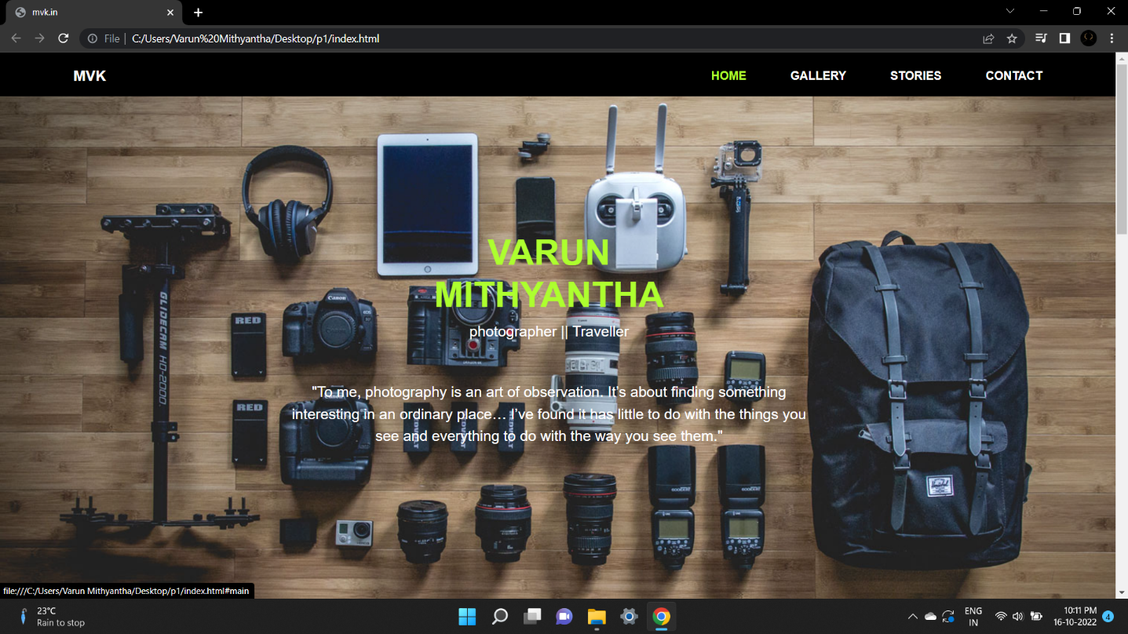

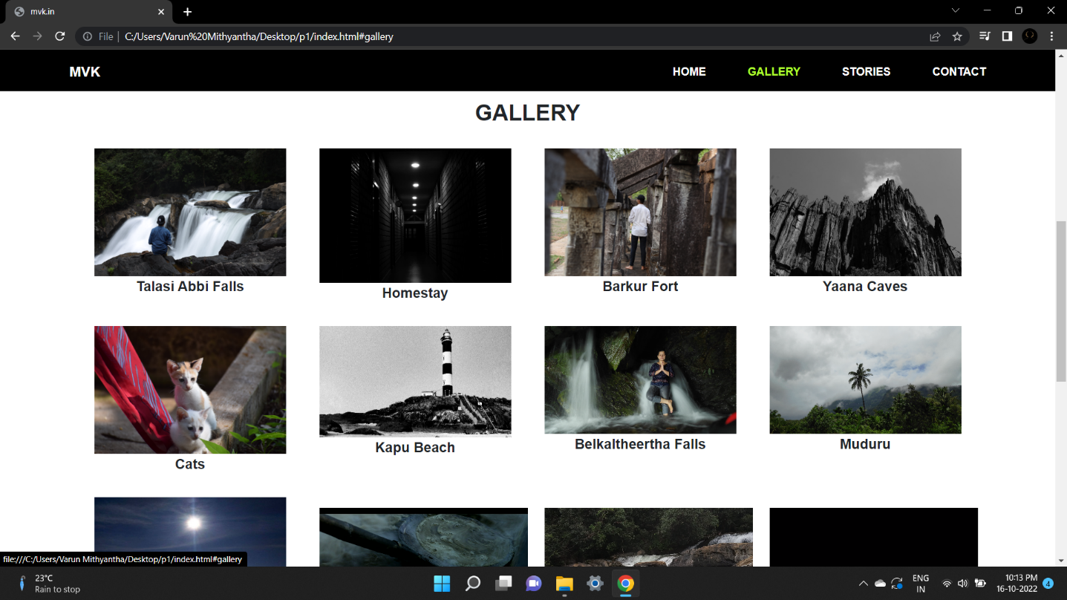

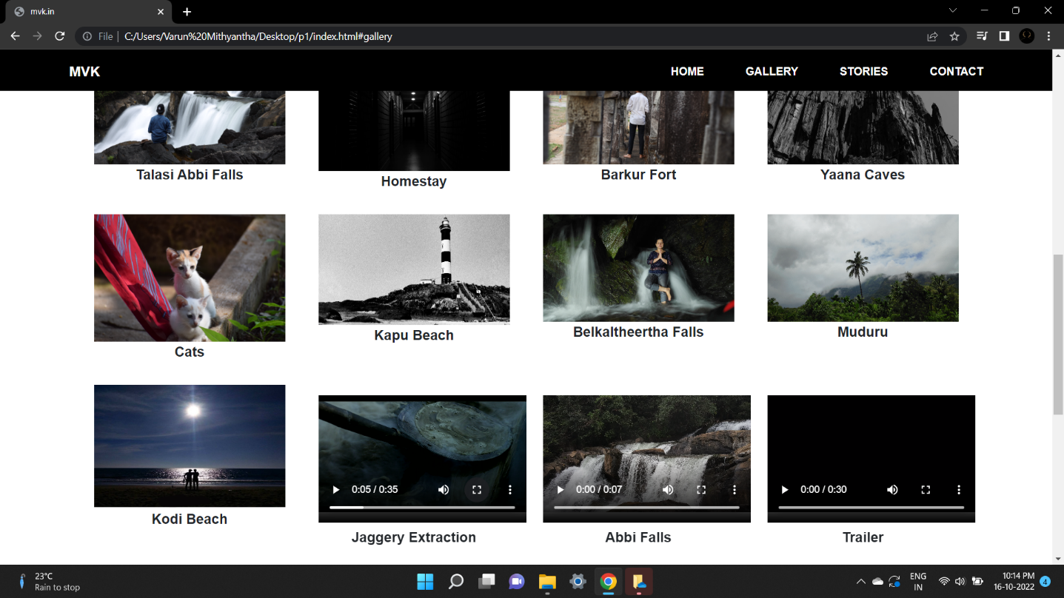

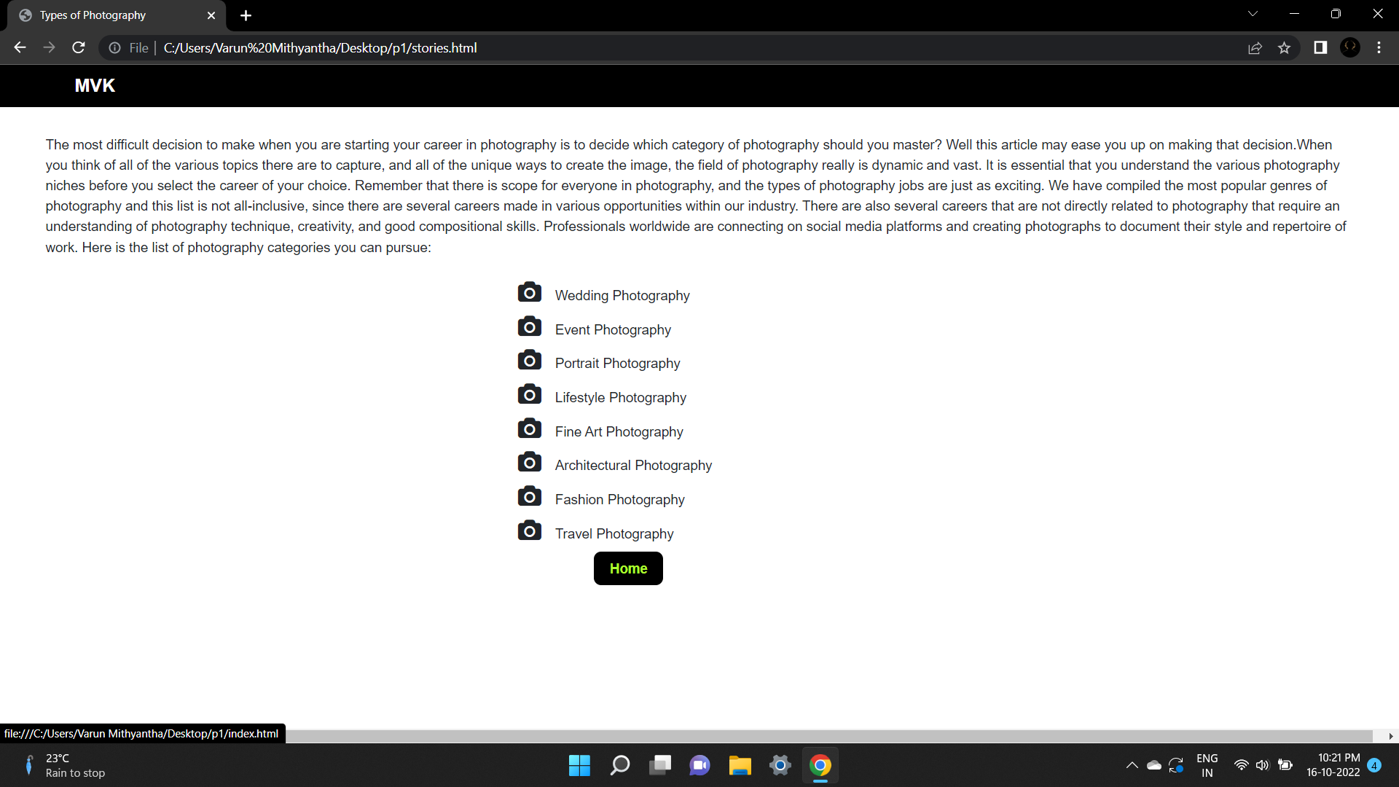

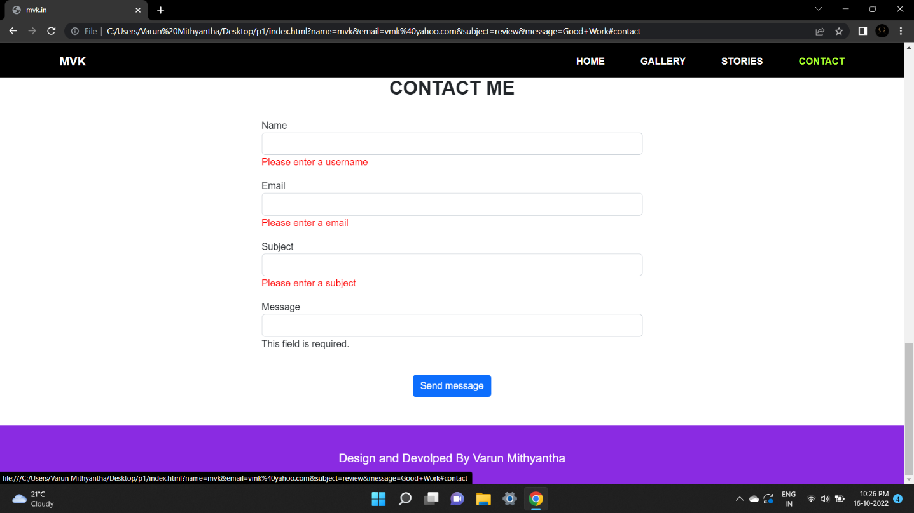

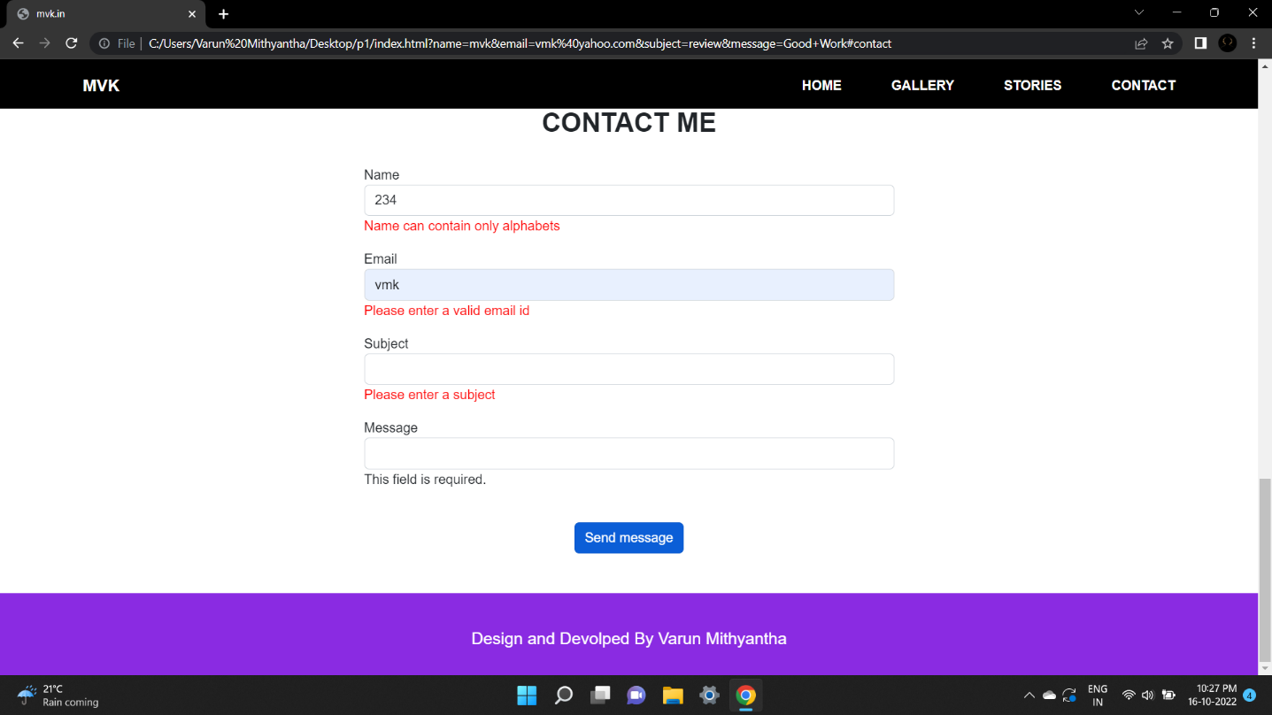

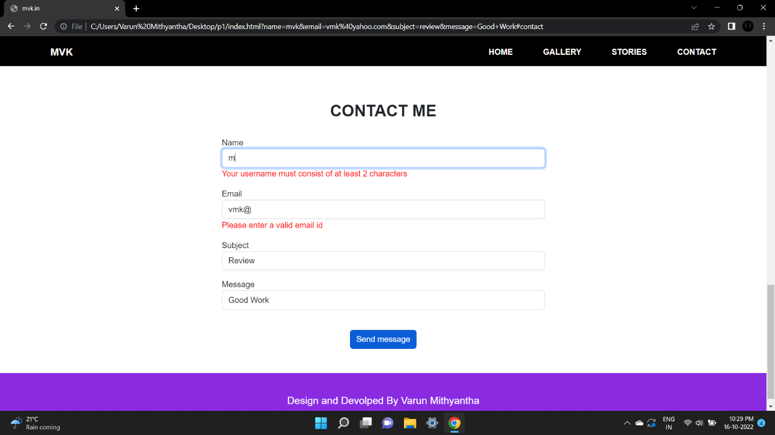

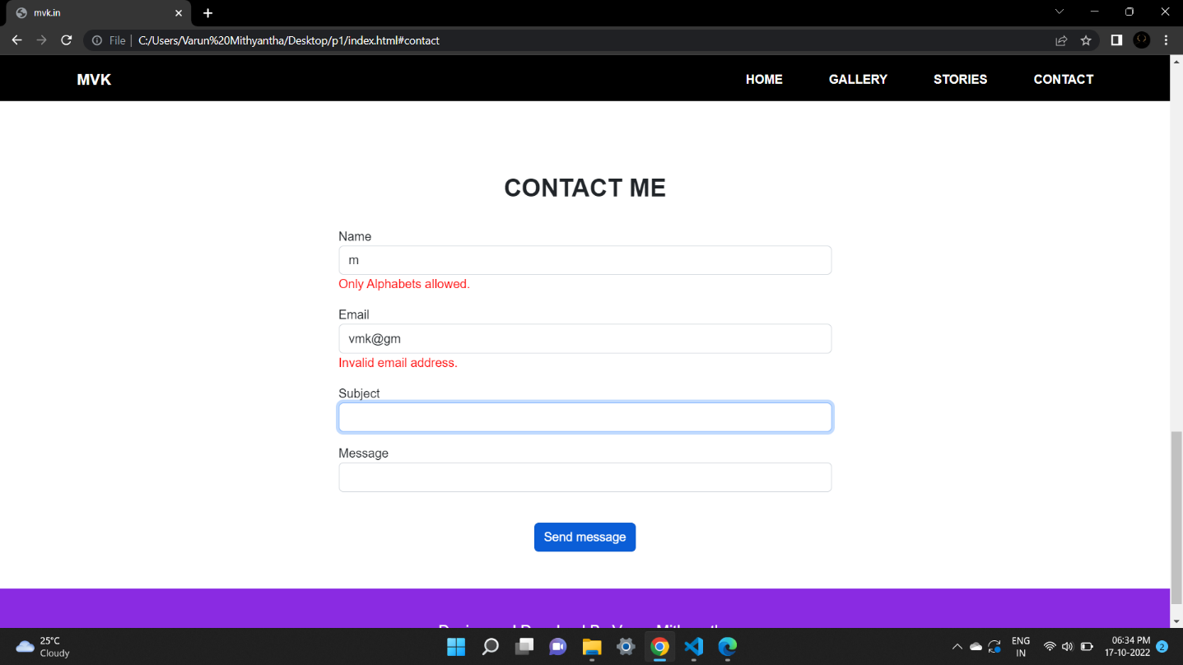

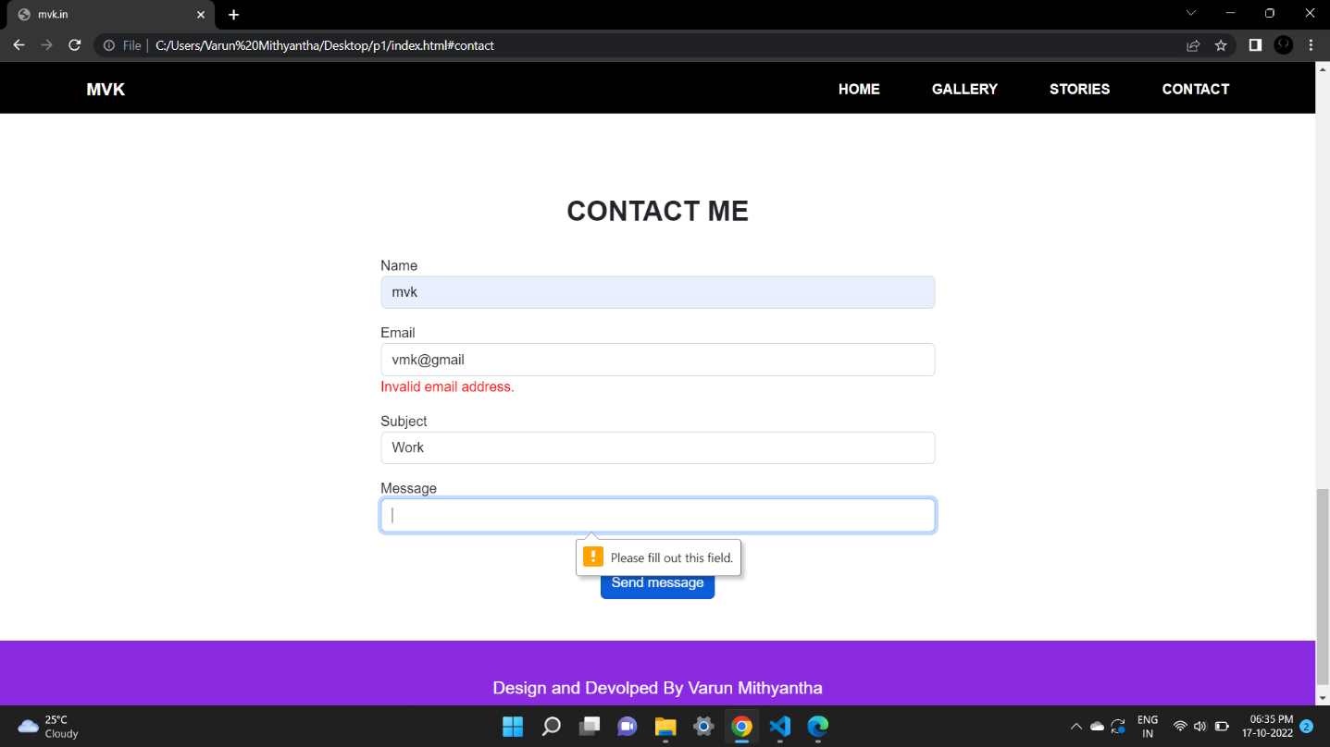

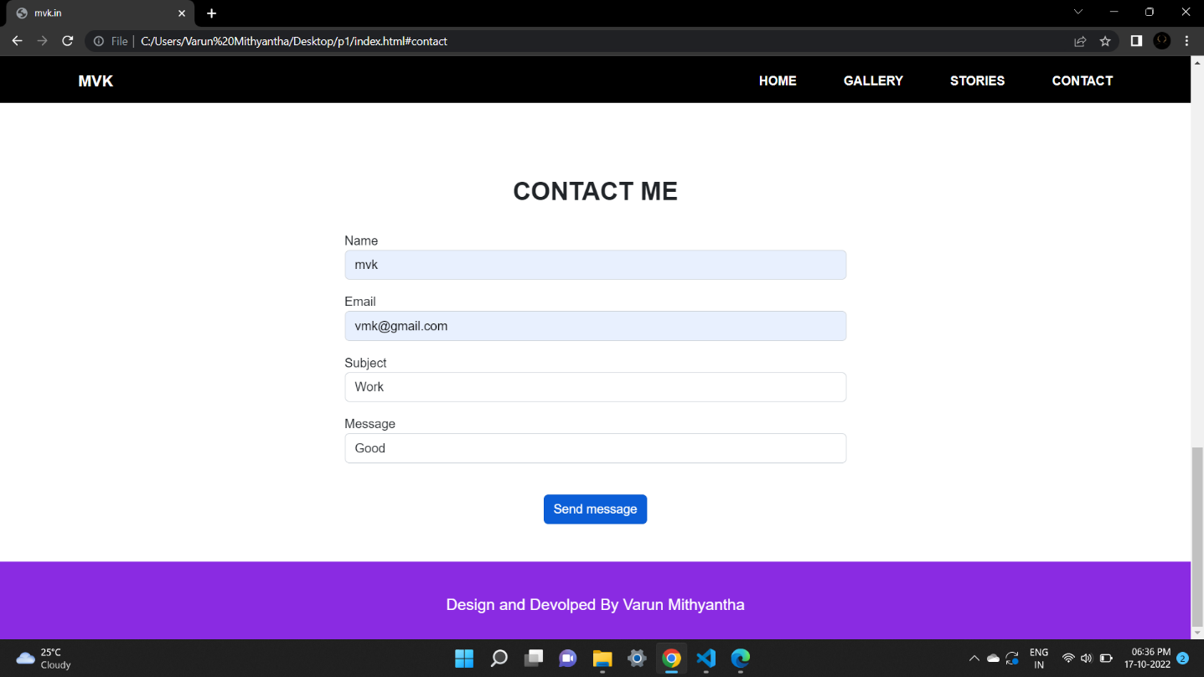

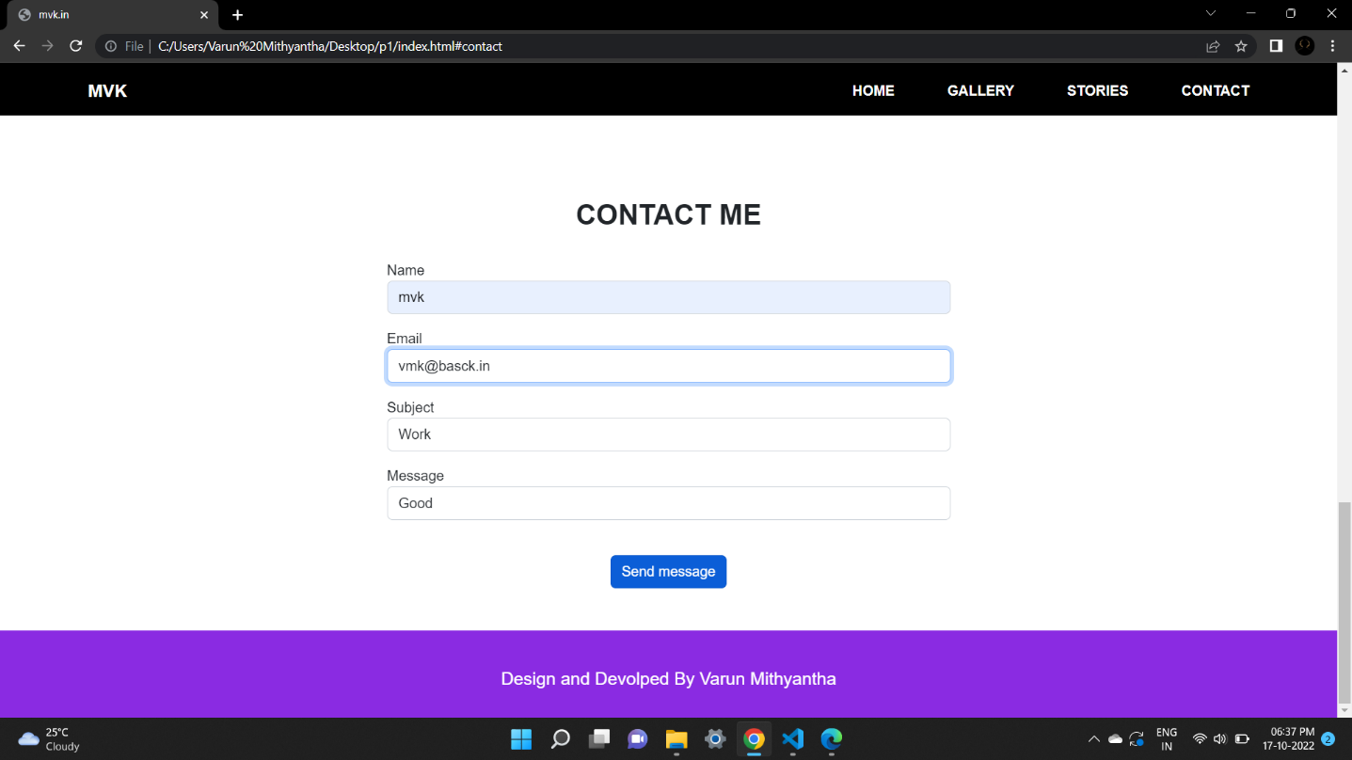

### **Tools and Technologies**

**Requirements**

1. **Hardware Requirements :**

Processor : intel Pentium Dual Core or more

RAM : 2GB or more

Hard Disk : 164GB or more.

1. **Software Requirements :**

Front End – Notepad++, Google Chrome Browser

Operating System : Windows 7 or more.

1. **Languages :** HTML5, CSS, JQuery, Bootstrap.

**Limitation of the project:**

* Connection to the Internet is needed.
* Image View in larger size is currently not possible.

**Future scope and more project reinforcement:**

* We will be able to create mobile smartphone applications in the future.
* We will add multiple stories of Travel diaries in near future.
* Gallery images on click view in larger size will be added in future.
* The framework already serves desktop computers and we will be able to make web browsers compliant in the future.

### Bibliography

1. <https://www.w3schools.com/>
2. <https://www.geeksforgeeks.org/>
3. <https://getbootstrap.com/>
4. <https://en.wikipedia.org/>
5. <https://www.javatpoint.com/>
6. <https://www.tutorialspoint.com/>
7. [https://www.jquery.com/jquery-3.6.1.min.js/](https://code.jquery.com/jquery-3.6.1.min.js/)